**CASSANDRA**

**Perform the following DB operations using Cassandra.**

1.Create a keyspace by name Employee

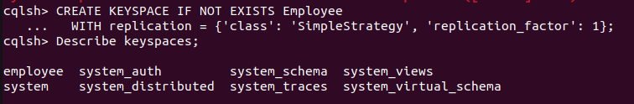

2. Create a column family by name Employee-Info with attributes Emp_Id Primary Key, Emp_Name, Designation, Date_of_Joining, Salary,Dept_Name

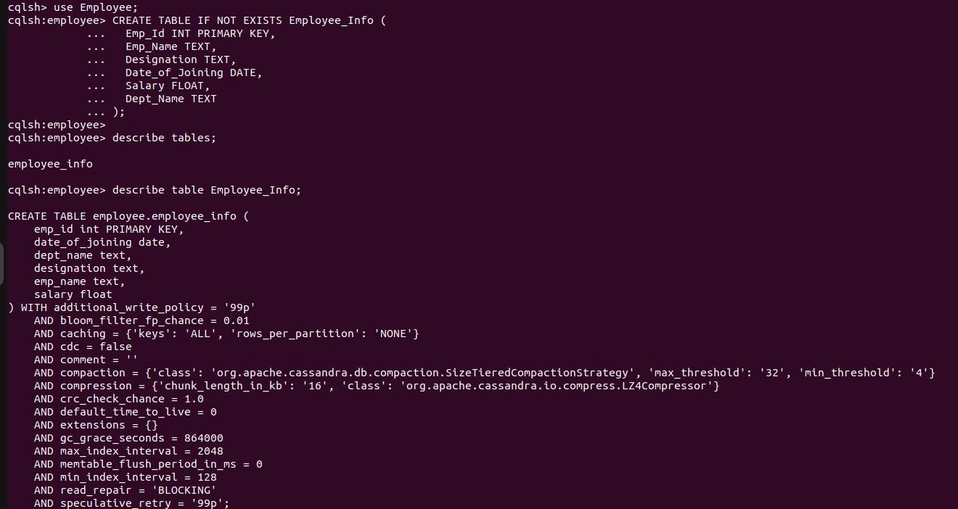

3. Insert the values into the table in batch

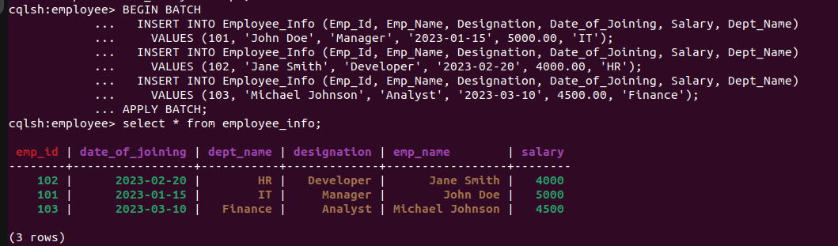

4. Update Employee name and Department of Emp-Id 102

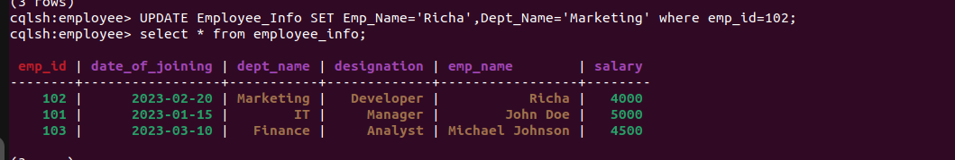

5. Sort the details of Employee records based on salary

6. Alter the schema of the table Employee Info to add a column Projects which stores a set of Projects done by the corresponding Employee.

7. Update the altered table to add project names.



8.Create a TTL of 15 seconds to display the values of Employees